Scenario 1
1NF
The given table is not in 1NF because some cells are merged. One student row has more than one activity, and one activity has more than one time slot. To convert it into 1NF, I split these merged cells so that each row shows them individually along with every cell having a single value.
The chosen primary key: (StudentID, Activity, ActivityTimings)
I chose this composite key because StudentID on its own is not unique, since one student can join many activities. StudentID and Activity together are also not unique, because a student can attend more than one time slot of the same activity.
ERD:
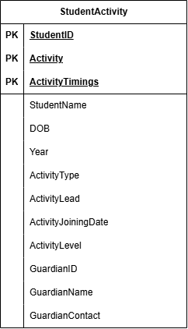

EXAMPLES:

2NF
Partial dependencies:
StudentID → StudentName, DOB, Year, GuardianID, GuardianName, GuardianContact
Activity → ActivityType
(Activity, ActivityTimings) → ActivityLead
(StudentID, Activity) → ActivityJoiningDate, ActivityLevel

ERD:
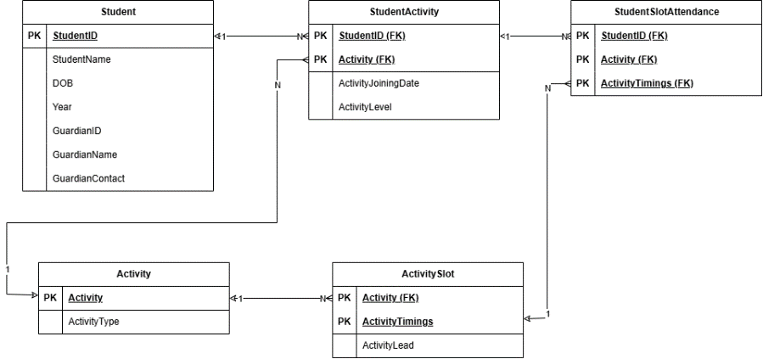
EXAMPLES:
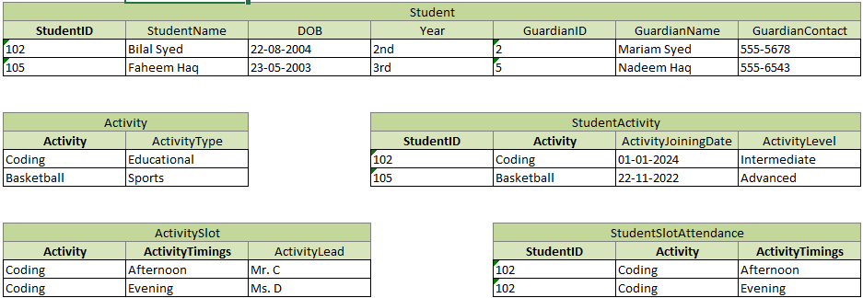

3NF
Transitive dependency:
StudentID → GuardianID → GuardianName, GuardianContact

ERD:
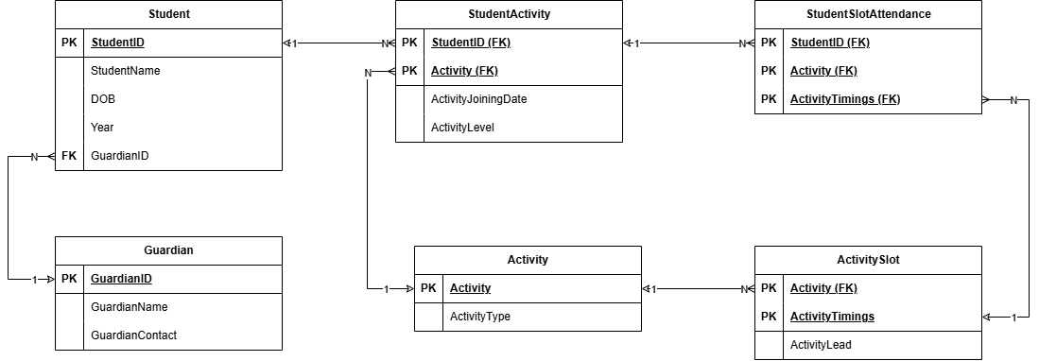

EXAMPLES:
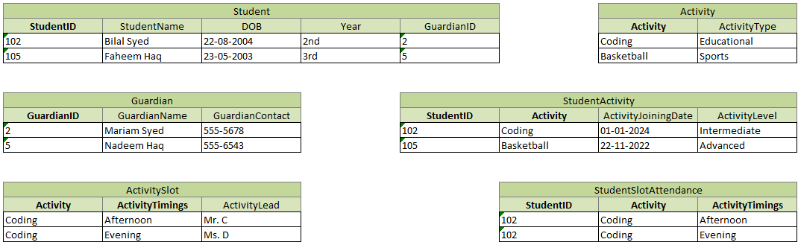
SCHEMA:
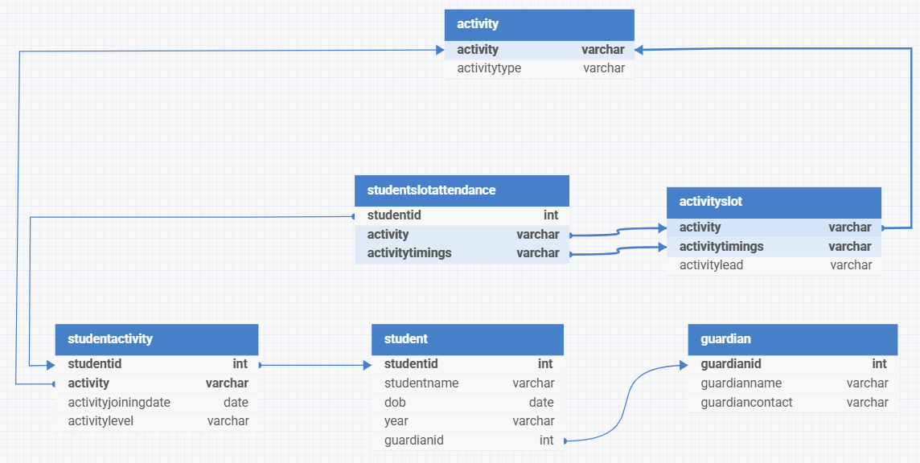

Scenario 2
1NF
Country, Category, Director, Cast and Producer hold multiple values, so they are moved into separate tables with MovieTitle, and every booked seat gets its own row.
The chosen primary key: (BookingID, SeatNumber)
A booking can have many seats, so BookingID alone is not unique. BookingID and SeatNumber together identify each ticket. The movie tables use all their columns as the key, since a movie has many countries, categories and crew. Director, Cast and Producer are combined into MovieCrew with a Role column, since one person can have more than one role.

ERD:

2NF
Partial dependencies:
BookingID → City, CinemaName, ScreenSize, Capacity, MovieTitle, ReleaseDate, Rating, Likes, Dislikes, ShowDate, ShowTime, Format, TicketPrice, NoOfSeats, TotalAmount, SeatPreference
ERD:

